**Figure S1.** Plot of genome-wide significant *ADAM10* locus

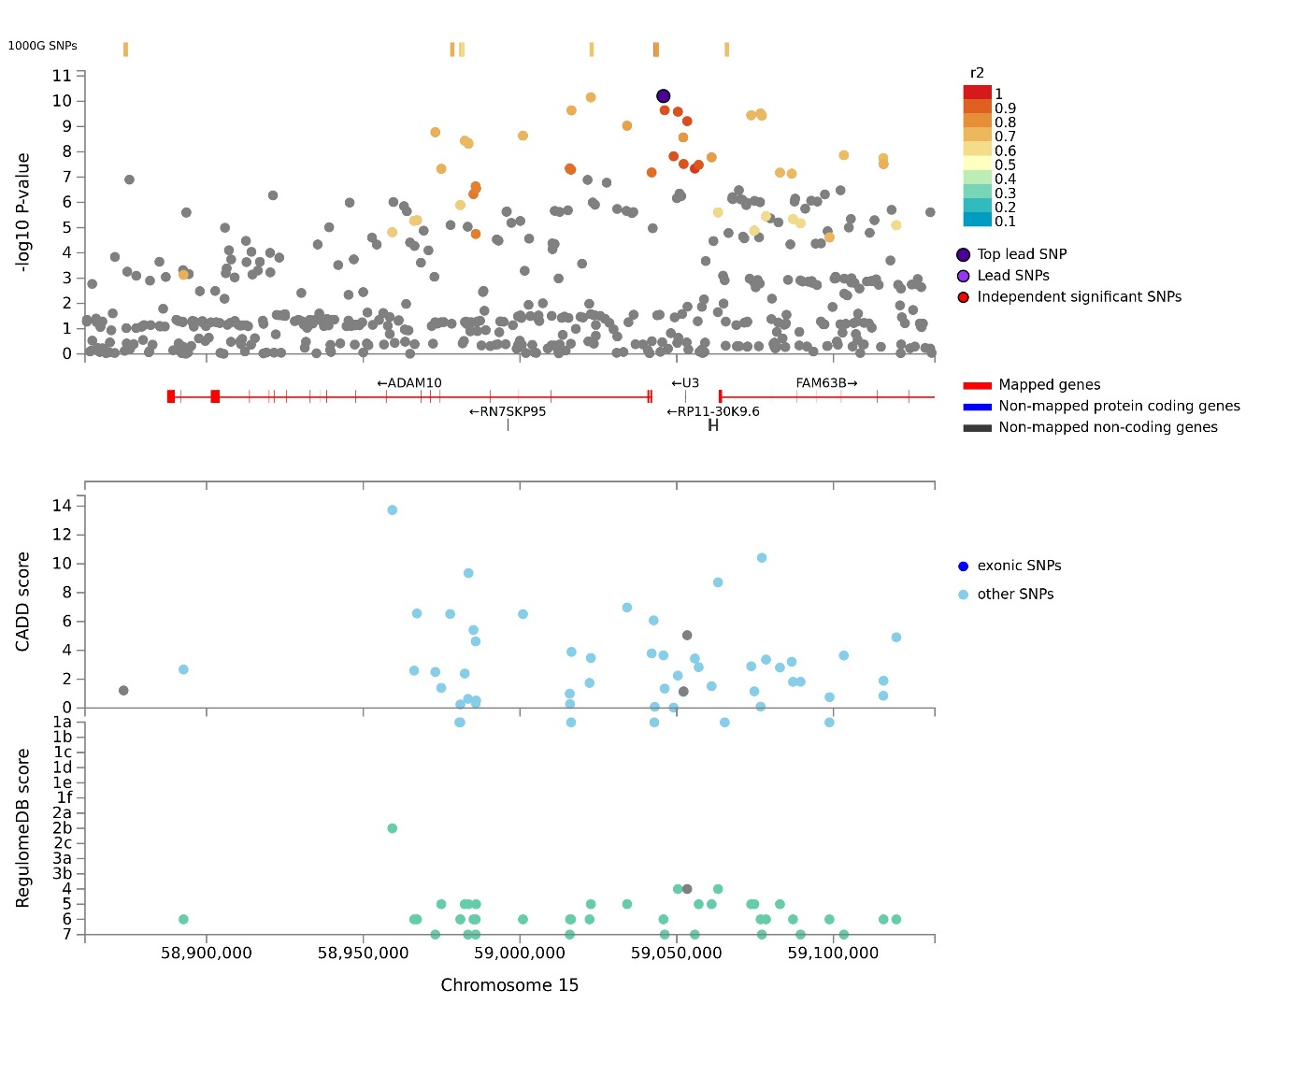

**Figure S2.** Plot of genome-wide significant *BCKDK* locus

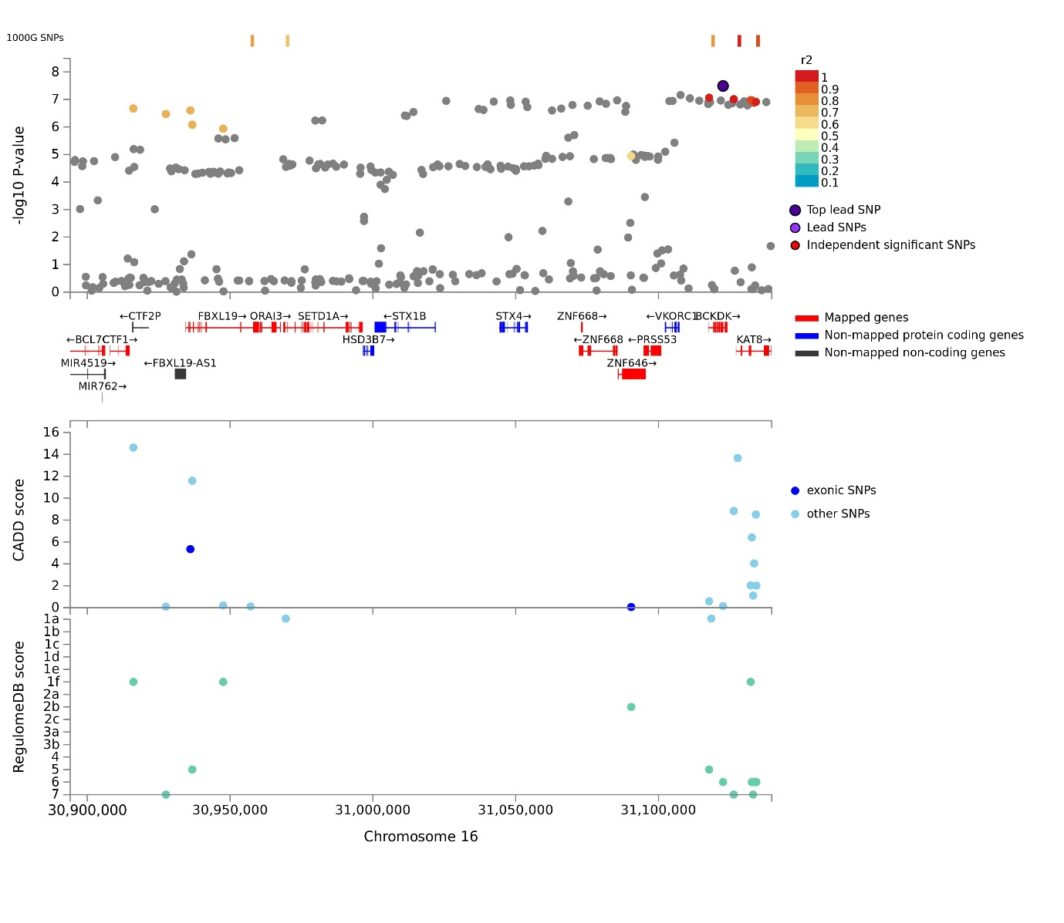

**Figure S3.** Plot of genome-wide significant *ACE* locus

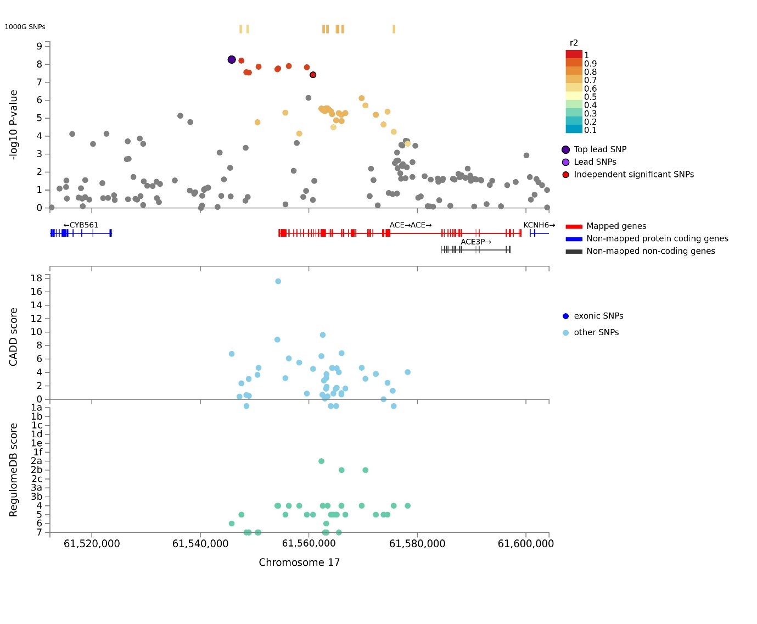

**Figure S4.** SMR and HEIDI plot of *KAT8* (eQTL analysis)

U:\Datastore\IGMM\marioni-lab\Riccardo\AD_GWAS_UKB\Trans_Psych_submission\Trans_Psych_submission\KAT8.locus.tiff

U:\Datastore\IGMM\marioni-lab\Riccardo\AD_GWAS_UKB\Trans_Psych_submission\Trans_Psych_submission\KAT8.heidi.tiff

**Figure S5.** SMR and HEIDI plot of *EXOC3L2* (methQTL analysis)

U:\Datastore\IGMM\marioni-lab\Riccardo\AD_GWAS_UKB\Trans_Psych_submission\Trans_Psych_submission\EXOC3L2.locus.tiff

U:\Datastore\IGMM\marioni-lab\Riccardo\AD_GWAS_UKB\Trans_Psych_submission\Trans_Psych_submission\EXOC3L2.heidi.tiff

**Figure S6.** SMR and HEIDI plot of *STAG3* (methQTL analysis) U:\Datastore\IGMM\marioni-lab\Riccardo\AD_GWAS_UKB\Trans_Psych_submission\Trans_Psych_submission\STAG3.locus.tiff U:\Datastore\IGMM\marioni-lab\Riccardo\AD_GWAS_UKB\Trans_Psych_submission\Trans_Psych_submission\STAG3_cg00553149.heidi.tiffU:\Datastore\IGMM\marioni-lab\Riccardo\AD_GWAS_UKB\Trans_Psych_submission\Trans_Psych_submission\STAG3_cg04778012.heidi.tiff